Insight Schools of California
Face-2-Face Event

Location/Event Title: Getty Center Picnic

Date: 3/20/2020

Time: 12:30-2:30pm

Address: 1200 Getty Center Dr., Los Angeles CA 90049

Website: https://www.getty.edu/

Cost: free; parking is $20

Other Info: Bring lunch or buy lunch there and enjoy a picnic on the lawn!
Teacher Chaperones/Contact Info:
- Mary Guzman- 323-844-3198 mguzman@k12insightca.org

Event Description
Join us for a picnic at the lawn of the Getty Center and enjoy the gardens and exhibits.

Check-in Info
Meet us on the lawn for our picnic. See attached map on where to find us.

Items to bring
- Liability Release Form
- Photo/Video Release Form
- Driver’s Consent Form (if not accompanied by a parent)

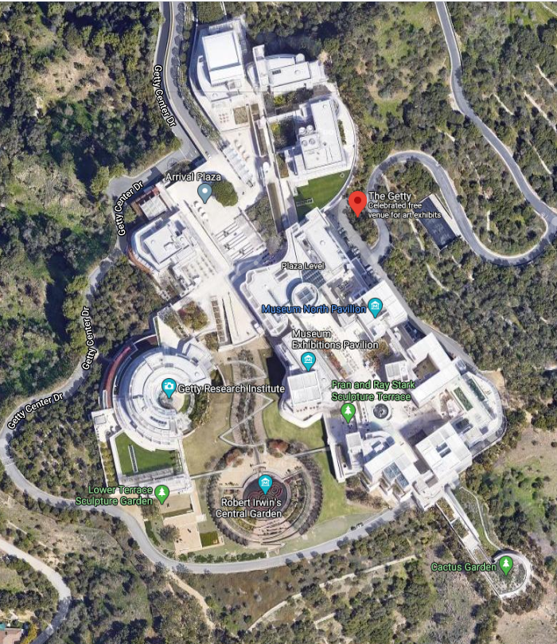
Meet us here for our picnic
Arrive here from tram

