Insight Schools of California
Face-2-Face Event

Location: ULTIMATE SRIRACHA TOUR at Huy Fong Foods Inc. Factory

Date: February 24, 2020

Time: 12:30pm

Address: 4800 Azusa Canyon Rd., Irwindale, 91706

Website: https://www.huyfong.com/toursnow/

Cost: FREE!

Other Info: Must wear CLOSED TOED SHOES or will not be able to attend tour! Cameras are welcomed.
Teacher Chaperones/Contact Info:
- Jennifer Lee (562) 507-1771 email: jklee@k12insightca.org

Event Description
This is a 45-60-minute walking tour to experience the hard work and dedication behind the production of Sriracha Sauce.
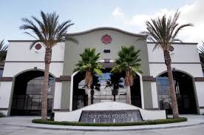
Check-in Info
Please wait and check in outside, in front of the building.

Items to bring
- Liability Release Form
- Photo/Video Release Form
- Driver’s Consent Form (if not accompanied by a parent)

